1st Semester (84 Days)  1st Quarter: August. 14 – October. 11  2nd Quarter: October. 18 – December 21  2nd Semester (106 Days)  3rd Quarter: January. 15 – March 22  4th Quarter: March 25 – June 21  7 – 10 School preparation  11 PARENT ORIENTATION  14 1st Day of Class/  Student Orientation  21 - 25 SSG Filing  28 SSG Election |  |  |  | 9 - 12 Chinese New Year  13 - 16 SIA School Spirit Week  16 Worship Fellowship
  AUGUST 2023
  S | M | T | W | Th | F | S
   |  | 1 | 2 | 3 | 4 | 5
  6 | 7 | 8 | 9 | 10 | 11 | 12
  13 | 14 | 15 | 16 | 17 | 18 | 19
  20 | 21 | 22 | 23 | 24 | 25 | 26
  27 | 28 | 29 | 30 | 31
  FEBRUARY 2024
  S | M | T | W | Th | F | S
   |  |  |  | 1 | 2 | 3
  4 | 5 | 6 | 7 | 8 | 9 | 10
  11 | 12 | 13 | 14 | 15 | 16 | 17
  18 | 19 | 20 | 21 | 22 | 23 | 24
  25 | 26 | 27 | 28 | 29
1 Worship Fellowship  25 Constitution Day  26 – 29 SIA Foundation Week  -Founder’s Day  -Academic Contest  -SIA’s Got Talent  -Sport’s Day |  |  |  | 4 – 7 SCHOOL RETREAT  8 Holiday  20 – 22 3rd Quarter Test  22 End of 3rd Quarter  25 Beginning of 4th Quarter  29 3rd Quarter Recognition  Pre-Easter Chapel
  SEPTEMBER 2023
  S | M | T | W | Th | F | S
   |  |  |  |  | 1 | 2
  3 | 4 | 5 | 6 | 7 | 8 | 9
  10 | 11 | 12 | 13 | 14 | 15 | 16
  17 | 18 | 19 | 20 | 21 | 22 | 23
  24 | 25 | 26 | 27 | 28 | 29 | 30
  MARCH 2024
  S | M | T | W | Th | F | S
   |  |  |  |  | 1 | 2
  3 | 4 | 5 | 6 | 7 | 8 | 9
  10 | 11 | 12 | 13 | 14 | 15 | 16
  17 | 18 | 19 | 20 | 21 | 22 | 23
  24/31 | 25 | 26 | 27 | 28 | 29 | 30
5 Teacher’s Appreciation Day  Worship Fellowship  9 - 11 1st Quarter Test  11 End of 1st Quarter  12 – 17 Pchum Ben  18 Beginning of 2nd Quarter  23 1st Quarter Recognition  30 King’s Coronation Day |  |  |  | 11 Worship Fellowship  Khmer New Year Activity  12 - 17 Khmer New Year  22 - 26 Parent Teacher’s Conference
  OCTOBER 2023
  S | M | T | W | Th | F | S
  1 | 2 | 3 | 4 | 5 | 6 | 7
  8 | 9 | 10 | 11 | 12 | 13 | 14
  15 | 16 | 17 | 18 | 19 | 20 | 21
  22 | 23 | 24 | 25 | 26 | 27 | 28
  29 | 30 | 31
  APRIL 2024
  S | M | T | W | Th | F | S
   | 1 | 2 | 3 | 4 | 5 | 6
  7 | 8 | 9 | 10 | 11 | 12 | 13
  14 | 15 | 16 | 17 | 18 | 19 | 20
  21 | 22 | 23 | 24 | 25 | 26 | 27
  28 | 29 | 30
Oct. 31 – Nov. 3  Parent Teacher’s Conference  9 Independence Day  23 SIA Thanksgiving Day  Worship Fellowship  27 - 29 Water Festival  26 – December 1  Regional Student Convention Thailand  (Tentative) |  |  |  | 1 Labor Day  2 – 3 International Day  6 – 10 Juniors & Seniors Trip (Tentative)  14 King’s Birthday  17 School Field Trip  31 SPOKEN WORD – Grand Finale
  NOVEMBER 2023
  S | M | T | W | Th | F | S
   |  |  | 1 | 2 | 3 | 4
  5 | 6 | 7 | 8 | 9 | 10 | 11
  12 | 13 | 14 | 15 | 16 | 17 | 18
  19 | 20 | 21 | 22 | 23 | 24 | 25
  26 | 27 | 28 | 29 | 30
  MAY 2024
  S | M | T | W | Th | F | S
   |  |  | 1 | 2 | 3 | 4
  5 | 6 | 7 | 8 | 9 | 10 | 11
  12 | 13 | 14 | 15 | 16 | 17 | 18
  19 | 20 | 21 | 22 | 23 | 24 | 25
  26 | 27 | 28 | 29 | 30 | 31
DECEMBER FESTIVITIES  8 SPOKEN WORD (Mid-year)  11 – 12 Academic Evaluation  13 - 15 MIDTERM TEST  19 MIDYEAR MERIT SALE  20 Christmas Chapel & Party  Worship Fellowship  21 Christmas Program  End of 2nd Quarter  December 22 – January 12  Holiday Break |  |  |  | 7 Worship Fellowship  High School Night  10 - 14 FINAL TEST WEEK  17 - 18 Completion Days  19 4th Quarter Recognition  & Grand Merit Sale  20 Final Rehearsal Day  21 Awards, Moving Up, and  7th Graduation Ceremony
  DECEMBER 2023
  S | M | T | W | Th | F | S
   |  |  |  |  | 1 | 2
  3 | 4 | 5 | 6 | 7 | 8 | 9
  10 | 11 | 12 | 13 | 14 | 15 | 16
  17 | 18 | 19 | 20 | 21 | 22 | 23
  24/31 | 25 | 26 | 27 | 28 | 29 | 30
  JUNE 2024
  S | M | T | W | Th | F | S
   |  |  |  |  |  | 1
  2 | 3 | 4 | 5 | 6 | 7 | 8
  9 | 10 | 11 | 12 | 13 | 14 | 15
  16 | 17 | 18 | 19 | 20 | 21 | 22
  23/30 | 24 | 25 | 26 | 27 | 28 | 29
1 New Year's Day  15 Beginning of 3rd Quarter  17 2nd Quarter Recognition |  |  |  | June 24 – August 9  Summer Break  July 8 - 12 Teacher’s Retreat (Tentative)  July 15 – August 2  Summer Class  August 12  Beginning of SY 2024 - 2025  Legends:  SIA Events  Holidays/Breaks (No classes)
  JANUARY 2024
  S | M | T | W | Th | F | S
   | 1 | 2 | 3 | 4 | 5 | 6
  7 | 8 | 9 | 10 | 11 | 12 | 13
  14 | 15 | 16 | 17 | 18 | 19 | 20
  21 | 22 | 23 | 24 | 25 | 26 | 27
  28 | 29 | 30 | 31
  JULY 2024
  S | M | T | W | Th | F | S
   | 1 | 2 | 3 | 4 | 5 | 6
  7 | 8 | 9 | 10 | 11 | 12 | 13
  14 | 15 | 16 | 17 | 18 | 19 | 20
  21 | 22 | 23 | 24 | 25 | 26 | 27
  28 | 29 | 30 | 31
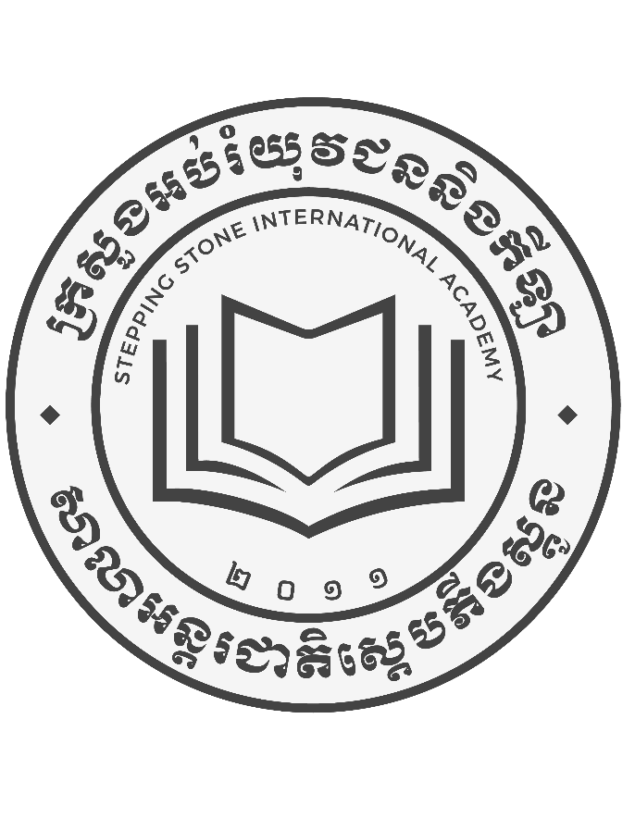

Stepping Stone International Academy
Home Page: www.siacambodia.come Email: siacambodia2011@gmail.com 93794962
#198 AB 42P Street, Sangkat Kork Kleang, Khan Sen Sok, Phnom Penh City, Cambodia

